**UBER TRIP ANALYSIS**

**Objective Analysis**

**Report 1: OVERVIEW ANALYSIS**

Analyse Uber trip data using Power BI to gain insights into booking trends, revenue, and trip efficiency, helping stakeholders make data-driven decisions.

**KPI’s**

1. **Total Bookings** – How many trips were booked over a given period?
2. **Total Booking Value** – What is the total revenue generated from all bookings?
3. **Average Booking Value** – What is the average revenue per booking?
4. **Total Trip Distance** – What is the total distance covered by all trips?
5. **Average Trip Distance** – How far are customers traveling on average per trip?
6. **Average Trip Time** – What is the average duration of trips?

Created a Measure Selector using a Disconnected Table with the following values:

* Total Bookings
* Total Booking Value
* Total Trip Distance

Then, use a measure to dynamically update the visualizations based on user selection.

**Location Analysis**

Understanding trip locations is crucial for optimizing ride distribution, demand forecasting, and operational efficiency. This analysis focuses on:

* **Most Frequent Pickup Point**
* **Most Frequent Drop-off Point**
* **Farthest Trip**

**Most Preferred Vehicle for Location Pickup**

* Determine the most frequently booked **vehicle type** at each pickup location.
* Supports strategic vehicle distribution based on customer preferences and location demand.

**Other Enhancements for Uber Trip Analysis Dashboard**

* **Bookmark for Data Details**
* **Page Navigator Buttons**

**Report 2: TIME ANALYSIS**

To understand trip patterns based on time, Uber needs to analyse ride demand and trends across different time intervals. This dashboard will help in optimizing operations, pricing, and driver availability.

**Global Dynamic Measure (Filters All Charts)**

A **measure selector** created for:  
✔ **Total Bookings**  
✔ **Total Booking Value**  
✔ **Total Trip Distance**  
This dynamic measure will update all visuals based on user selection.

**Visualizations:**

**By Pickup Time (10-Minute Intervals) - Area Chart**

* Groups trip bookings into **10-minute intervals** throughout the day.

**By Day Name - Line Chart**

* Shows booking trends across **Monday to Sunday**.
* Useful for analysing weekday vs. weekend demand.

**By Hour and Time - Heatmap (Matrix Grid)**

* **Rows:** Hours of the Day (0–23)
* **Columns:** Days of the Week (Mon-Sun)

**Report 3: DETAILS TAB**

To provide in-depth insights and allow users to explore granular data, a **Grid Tab** will be created. This tab will enable drill-through functionality, allowing users to access detailed records based on selections made in other dashboards.

**Features of the Grid Tab:**

* **Grid Table with Key Fields:**
* Displays essential trip details
* **Drill-Through Functionality:**
* Users can right-click on a data point from other visuals (e.g., charts, heatmaps) and **drill through to this Grid Tab**.
* Displays detailed records related to the selected data point.

**About the Dataset**

Dataset comprises of two tables which are in form of excel file format.

1. Location table
2. Trip Details table

A third and fourth table were created to cater better insights. They were created with cardinality one to many.

1. Dynamic Measures
2. Calendar table

|  |  |  |  |  |  |  |  |  |  |  |
| --- | --- | --- | --- | --- | --- | --- | --- | --- | --- | --- |
| **Trip ID** | **Pickup Time** | **Drop Off Time** | **passenger_count** | **trip_distance** | **PULocationID** | **DOLocationID** | **fare_amount** | **Surge Fee** | **Vehicle** | **Payment_type** |

Exhibit 1

Exhibit 1 depicts the columns which were provided in the data set in raw form in the TRIP DETAILS table.

TRIP DETAILS table contains total of 103729 Rows values. The dataset comprises of trips only for the month of June 2024.

Here are the specifics of each Attributes:

Trip ID: Unique ID to identify each trip.

Pickup Time: Time when Uber picked up the customer.

Drop Off Time: Time when Uber dropped off the customer

Passenger_count: Number of travellers in the car in that trip.

Trip_distance: Total distance of the trip from pickup to dropoff.

PULocationID: Location ID for the Pickup

DOLocationID: Location ID for the dropoff.

Fare_amount: Charges for the trip

Surge_fee: Extra charges for the trip during peak hours.

Vehicle: Type of vehicle such as sedan , Uber Green, UberX, Uber XL.

Payment_type: Type of payment such as google pay , uber pay, amazon pay , cash etc.

**Attributes in Location Table**

|  |  |  |
| --- | --- | --- |
| **LocationID** | **Location** | **City** |

Exhibit 2

Exhibit 2 contains attributes of the location file or table.

LocationID: Unique ID for the location

Location: Name of the location   
City: City where the location is situated.

**Exhibits with its explanations and objectives.**

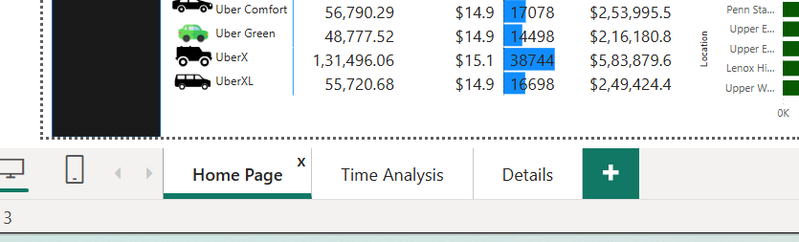

Exhibit 3

Exhibit 3 explains about 3 Reports pages.

1>Home page

2>Time Analysis

3>Details

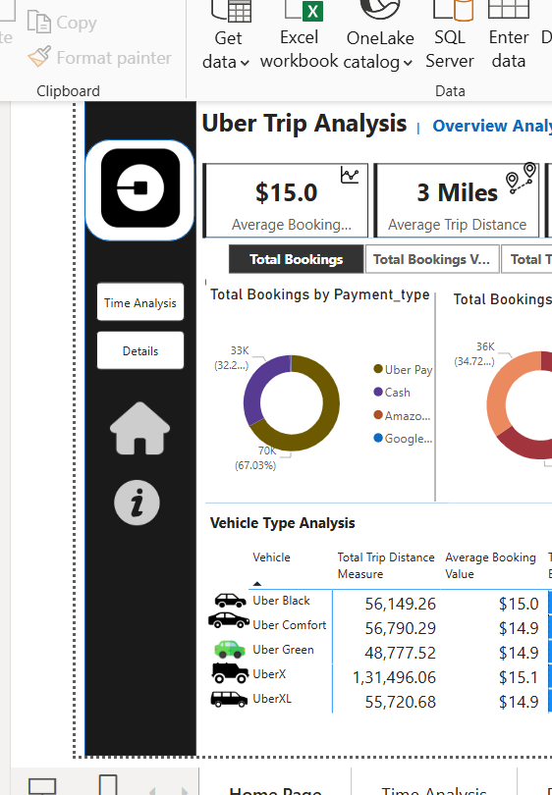

Exhibit 4

Exhibit 4 depicts an Uber Logo. It contains page navigation to the other 2 reports Time Analysis, Details. A home icon to return to the home page with no filters. The “I” icon has a URL attached with the Linkedin page of Harshnil Chawda.

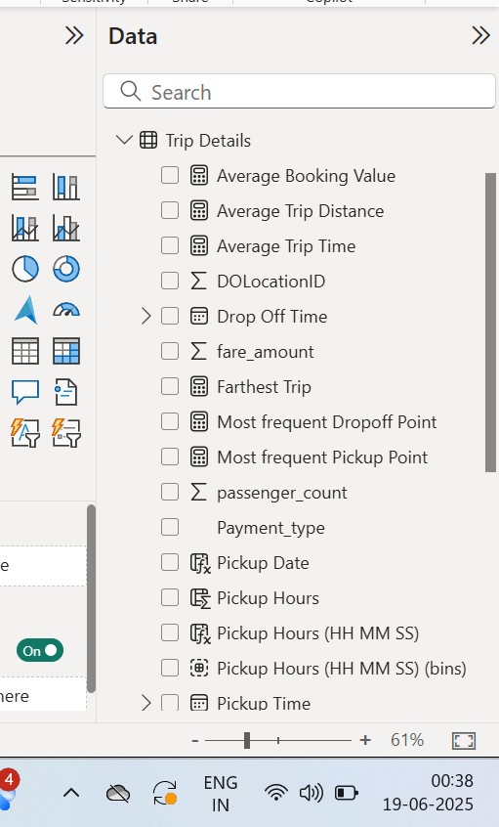

Exhibit 5

Exhibit 5 depicts new measures and columns created apart from the attributes that were already given in the trip table in the raw data file.

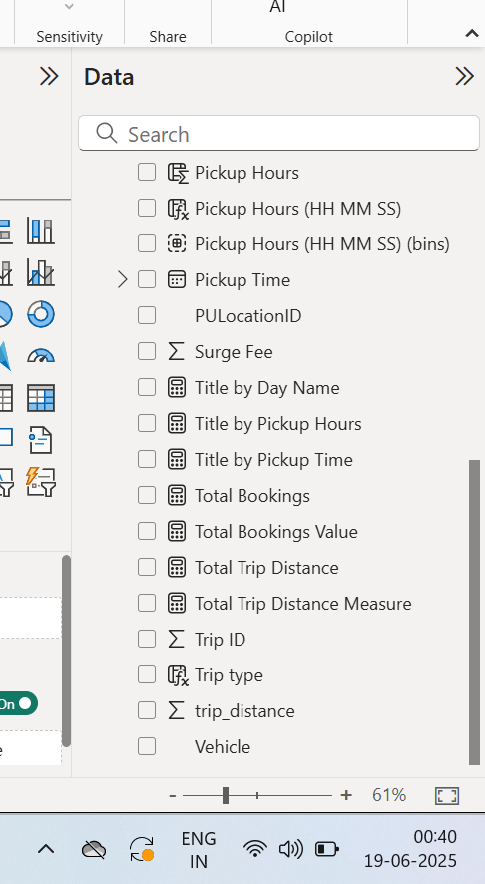

Exhibit 6

A few more columns and measures.

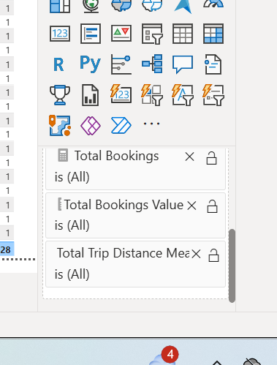

Exhibit 7

Drill through parameters which are our key KPI’s for analysis on all three reports.

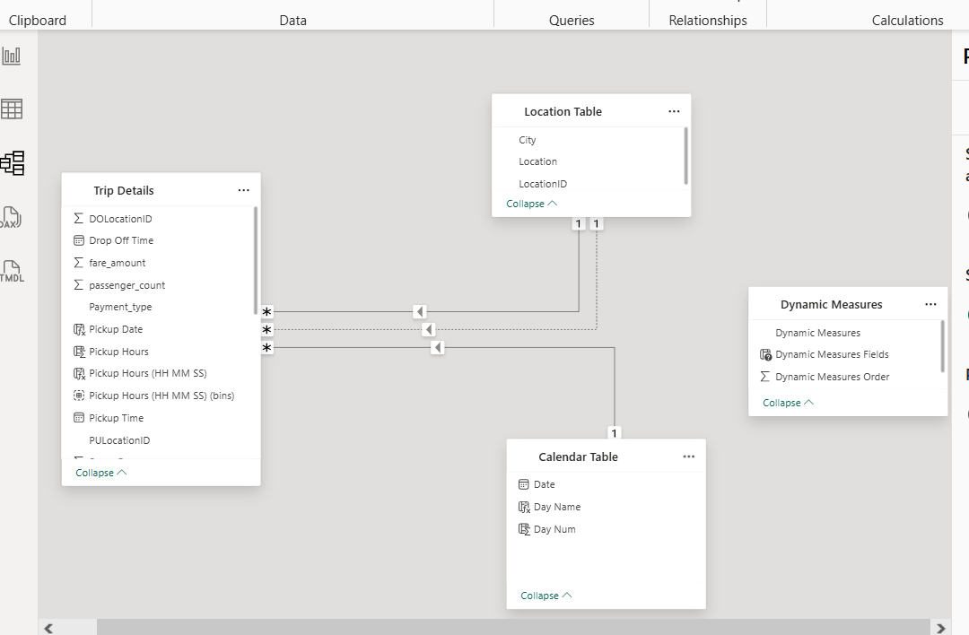

Exhibit 8

Exhibit 8 depicts the data modelling, relationships, data transfer , cardinality between all the tables. Here Location ID in the Location Table is connected with PULocation ID which is pickup location Id and the relationship is active. DOLocation id has inactive relationship with the locationID in the Location table and is activated only when needed and invoked which is why we have two relationships connecting both tables.

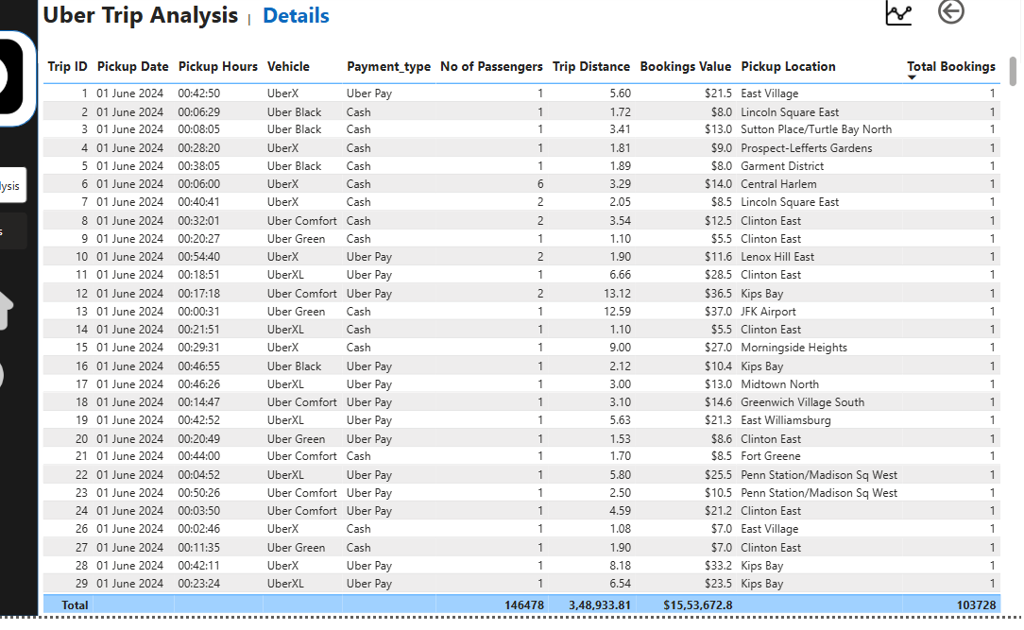

Exhibit 9

Exhibit 9 reveal us about all predominant KPI’s in the whole dashboard consisting of all 3 reports. This table helps us to extract all drill through requests from any page and extracted that data in here. This extracted data can also be further exported as per business needs.

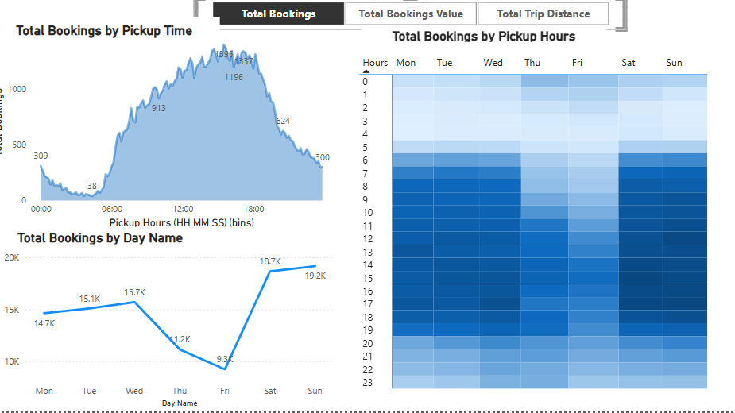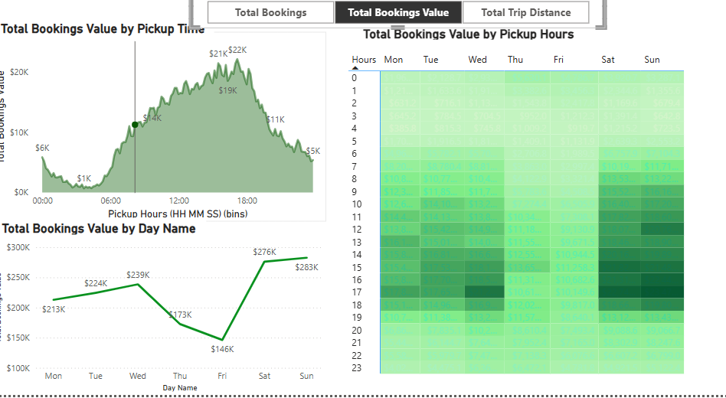

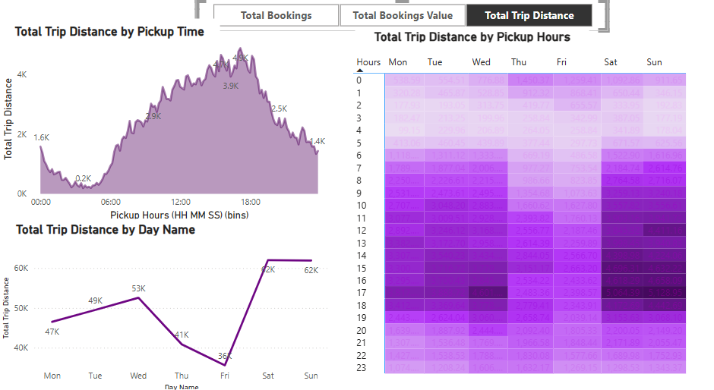

Exhibit 10: It depicts us 3 visuals out of our 3 main KPI’s Total Bookings, Total Bookings value and total trip distance.

**Findings for us**

* **Highest number of bookings have been booked by Uber Pay and Cash 67% and 32% respectively.**
* **UberX is the vehicle type which creates maximum number of bookings with highest total bookings Revenue($583,879) with total trip distance of 131496 miles.**
* **26th day of the month has the highest bookings 4947.**
* **Most frequent dropoff point is Upper East Side North.**
* **The longest trip recorded was between Lower east side and crown heights north with 144 miles.**
* **As the most frequent pickup point is Penn State Madison Square West it has the highest number of bookings 4.5 K.**
* **65% of Bookings come during the day time counting from 6 AM to 5 PM in the eve.**
* **The average trip distance recorded is 3 miles with 16 minutes in total.**
* **The total bookings value which is the total Revenue is $1.5 million.**
* **Highest number of bookings have come at 3:30 PM in the whole month which is 1396.**
* **Out of 7 days , Sunday has the highest bookings which is 19165.**
* **Saturday, Sunday i.e the week ends are the peak days for UBER generating maximum revenue.**